**Sprint 4 Plan - RetailGo - 11/24/23**

Goal: Implement fine-grained access control for different employee roles and recommendations to improve sales. Polish and refactor front and backend components.

**Task listing:**

* **User Story 1:** As an owner, I want to be able to manage my employees, so that there’s no unauthorized access to my store inventory or POS.
  + Implement employee permissions (10)
  + DoD:
    - Owner: Can choose permission level for each employee
    - Owner: Can edit permission level for each employee
    - Owner: Can access all pages and perform CRUD on each page.
    - Employee: Can access all pages that are allowed as per owner (for levels 0, 1, 2)
    - Employee: Cannot access any pages that are not allowed as per owner (For level 0)
    - Employee: Cannot perform edit if not allowed (level 1)
    - Owner: Can add/update/see/delete employees
    - Employee: Can login to the store once the owner has added them.
  + **Total: 10 hours**
* **User Story 2:** As an owner, I want to better understand my store sales and stocks, so that I can improve sales.
  + Create Image Upload (10)
  + Implement content-based filtering recommendation engine (20)
  + DoD:
    - Can see relevant recommendations of products to sell contextualized by my store and products.
  + **Total: 30 hours**
* Additional Tasks:
  + Stripe Frontend (alt pages for Success/Fail) (2)
  + Category auto-labeling (10)
  + Get it ready for multiple stores (store registration needs to be integrated with all phases of using RetailGo) (5)
  + OpenAPI Compliance (2)
  + Complete Employee Backend Integration (5)
  + POS Integration (for loading items) (5)
  + Refactoring (10)
  + Unit Testing (5)
  + **Total: 41 hours**

**Team Roles:**

* David Nguyen -> Developer
* Apramay Singh -> Developer & Product Owner
* Jonathan Michel -> Developer & Scrum Master
* Leo Asatoorian -> Developer
* Giridhar Vadhul -> Developer
* Colby Frey -> Developer

**Initial Task Assignment:**

* David Nguyen - > Frontend refactoring
* Apramay Singh -> Amazon image uploading
* Jonathan Michel -> Backend access control
* Leo Asatoorian -> New Stripe Frontend
* Giridhar Vadhul -> Recommendation Engine
* Colby Frey -> Frontend access control

**Initial burnup chart - Sprint 4**

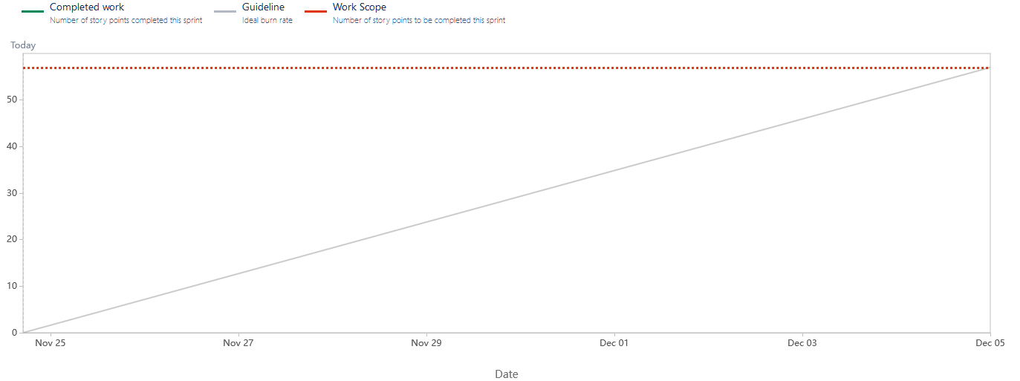

**Initial scrum board**

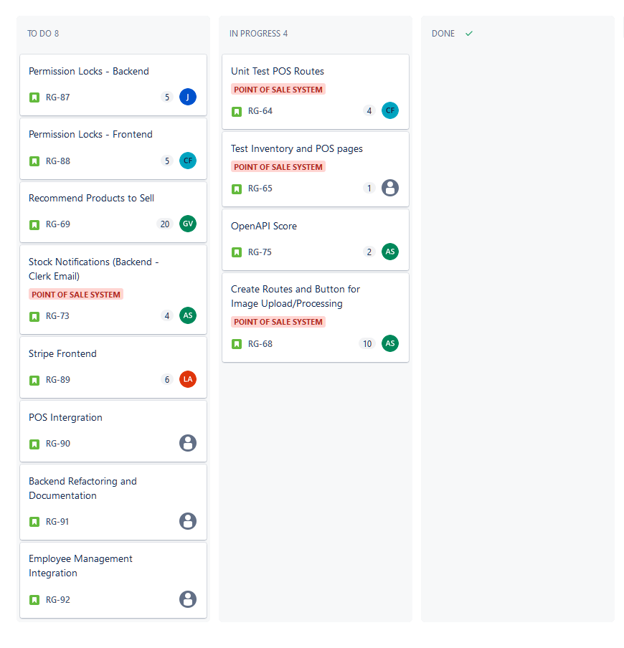

**Scrum Times:**

* Monday -> 4-6pm (including TA meeting)
* Thursday -> 4-5pm
* Saturday -> 4:30-5:30pm

**Code Coverage and Standards:**

**Code Style Standards:**

* [Go Standards](https://google.github.io/styleguide/go/)
* [React Standards](https://docs.google.com/document/d/1orMoX3i1HeLgftlLSGK4jBrwKV1NtFjr9eWxFTZMPFU/edit?usp=sharing)